Teaching Resources on the
Sustainable Management of Critical Raw Materials

Trainer’s Manual for
Critical Materials for Emerging Technologies

January 2020

Table of Contents
1. Context and Introduction to Training 3
1.1 Training Materials List 4
1.2 Suggested timetable 5
1.3 Key Messages 5
1.4 Learning Objectives 6
1.5 Additional Reading 6
2. Slides and Notes 7
3. Exercise 13
4. Acknowledgements and Authors 13
5. Citation 13
6. Disclaimer 14

1. Context and Introduction to Training

This booklet is supplementing the teaching materials and the set of further supporting booklets that have been developed to support teachers in conducting training courses related to the sustainable management of critical raw materials.
SusCritMat aims to educate people from Master’s student level up, both in industry and academia about important aspects of sustainable critical raw materials. In a novel concept, it introduces courses on these complex and interdisciplinary topics in a modular structure, adaptable to a variety of different formats and accessible to both students and managers in industry. These courses will develop new skills, which will help participants to better understand the impact and role of critical raw materials in the whole value chain; enabling them to identify and mitigate risks. Understanding the bigger picture and the interconnected nature of global business and society is increasingly necessary to and valued by industry.
SusCritMat is an EU-funded project that brings together the technical and pedagogical expertise of leading educational institutions and business partners. It uses and creates teaching materials which can be combined into different course formats.
The collection of training manuals presents the key messages related with the sustainable management of critical raw materials in three major sections:
- Introduction to criticality
- Analysis of criticality
- Solutions for sustainable management
In particular, the solutions part will be in the focus. The intention is to underline the possibilities that are available to approach and implement a circular economy for critical raw materials and the products bearing these. Doing so the concrete actions, i.e. the things that can be done, are highlighted, instead of only mentioning all sorts of associated problems or barriers in the context of CRMs.
The overall goal of the SusCritMat project is to qualify lecturers to teach the topics themselves. Therefore, the teaching resources do not only provide an introduction and improved insight into selected thematic issues, but also deliver a set of teaching materials “ready-to-use”.
- Learning targets that will be reached after having taught the courses
- Presentations on the specific topics including also notes on how to present the slides and key messages.
- Group work exercises including the task or question to work on, if applicable further reading on the methodology and the solutions in case of tasks requiring calculations.
- Assessment questions and the correct answers for each specific topic.
- Additional reading for each topic.

1.1 Training Materials List
The SusCritMat project developed the following teaching materials:
1 | Critical Resources for emerging technologies
2 | Circular Economy
3 | Criticality
4 | LCA
5 | Responsible Mining
6 | Responsible Sourcing/Certification
7 | Closing Loops on Product Level
8 | MFA
9 | Geopolitical aspects
10 | Metals & CRM scenarios
11 | Sustainability Assessment
12 | Waste Management
13 | Simulation-based Design for Recycling
14 | Restricted Substances Legislation
15 | Historical solutions for CRM
16 | Characterizing the Urban Mine
17 | Environmental Aspects
18 | Process Models based on LCA
19 | Responsible Business Practices
20 | Supply chain resilience
21 | Sustainable materials usage
22 | CRM and Sustainable Development
23 | Circular Business Models
24 | Economy of rare metals
25 | Supply Risk factors
26 | Recycling
27 | Good Use of Data

1.2 Suggested timetable
The agenda contains a recommended timing for the lecture and exercises. However, depending on the pre-existing knowledge or group size the time can be extended.
- Lecture: 40 minutes

1.3 Key Messages
This training module introduces the role of critical metals for emerging technologies, a complex and dynamic field with a lot of incertainties, but a crucial role for the future. The module includes:
- A presentation giving an overview of the topic
- An exercise
This module introduces first the notion of criticality. Along with module 3 “Criticality” it can therefore also be used for students without any prior knowledge about the topic. It is then shown that most of the known elements in the periodic table are relatively scarce. The number of different materials and the total mass used has steadily been increasing along with technological progress, economic and population growth, but there is only a limited amount of resources and some materials are (already) extremely scarce. This should make students understand why we need criticality to take into account the implications of a material’s scarcity for our economy and society. To illustrate the complexity of this issue, the examples of a mobile phone, wind power and electric vehicles are used. These key technologies for the future and a green energy transition require very specific elements like cobalt, neodymium, nickel etc. Thus, the availability of these technologies is directly related to the availability of these materials, and their price is a reflection of their criticality.
But physical scarcity of resources is not the only problem, as many materials are extracted in only a few countries, which makes their supply subject to political influences by those countries and often also coincidental with human rights abuses and environmental pollution. Many materials are only mined in combination with other elements or are a byproduct of their extraction, which links the supply risks of those materials together. Increasing mineral scarcity could be solved by a circular approach to materials, but their dissipation into tiny amounts in the final products or into the environment through wear and tear or other processes makes their recovery often unprofitable or physically impossible today. Therefore, the goals of a Circular Economy should be the guiding principles for every production step along the whole value chain.

1.4 Learning Objectives
After following this course, the learner should be able to:

- Define criticality;
- Explain why materials’ scarcity is a problem for our economy and society;
- Understand that different devices require different, sometimes very scarcely available materials;
- Explain the effect of dissipation;
- Explain the idea of a circular economy;
- Explain which circular economy measures can help reduce criticality

1.5 Additional Reading

2. Slides and Notes
Slides are supplied in ppt format with annotations.
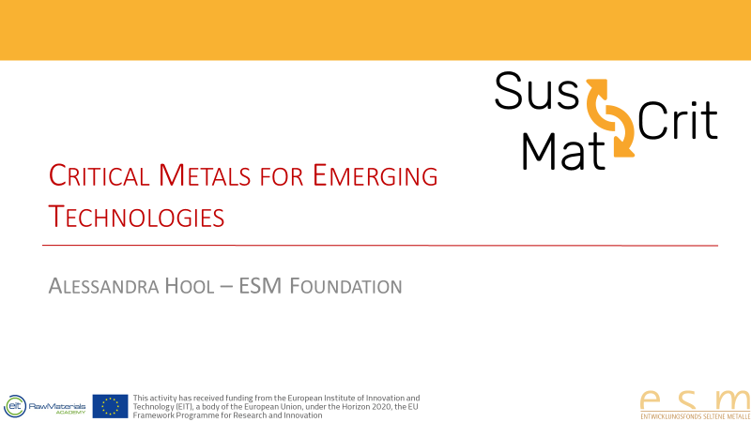
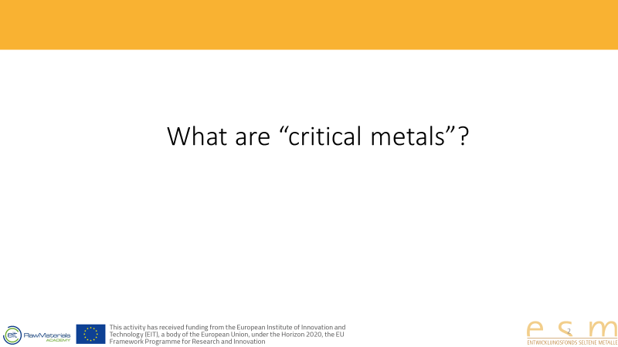
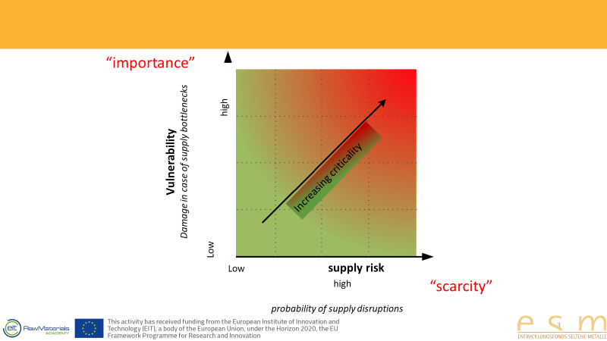 | The «criticality» of a metal is not a physical property like ist melting point. Instead, it is a notion used to summarize in one value the attention that should be paid to one metal or other element in order secure its supply. This necessary attention depends both on the importance of a certain material (for whatever country, territory or company in question) and its availabity. All criticality assessment methods combine these two factors (importance and scarcity).  Both factors each bundle numerous other factors, such as the degree of concentration of the available reserves, substitution potential, possibility to recycle, and so on.  In this module, we are going to look at a few key issues involving criticality.
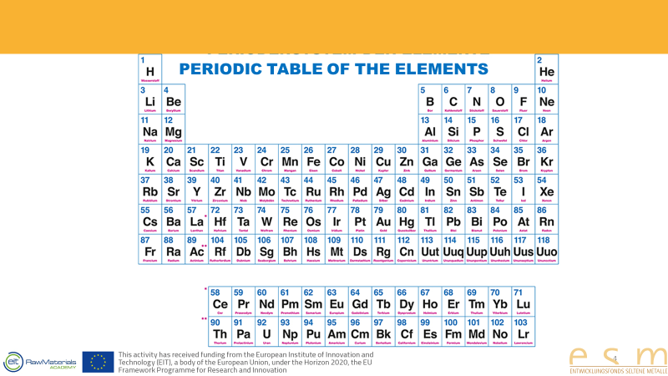 | - 92 natural elements  - Everything we know is made up of these elements!  - We need to cope with what we have
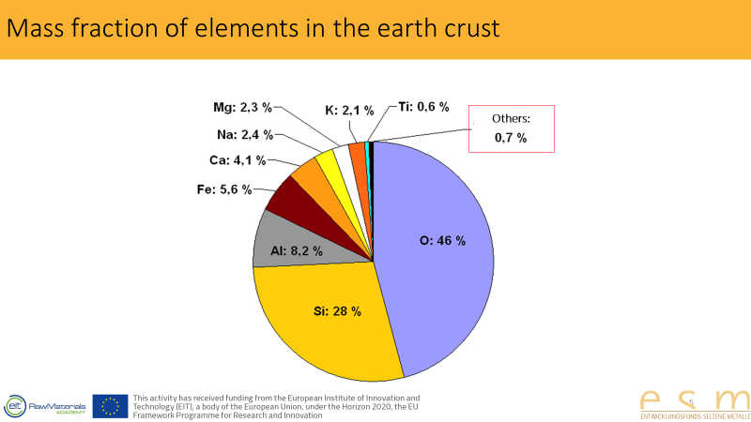 | - Unequally distributed  - Nine elements make up more than 99%  - Three quarters consist of oxygen and silicium, air and sand.  - All the other elements make up less than 1%.
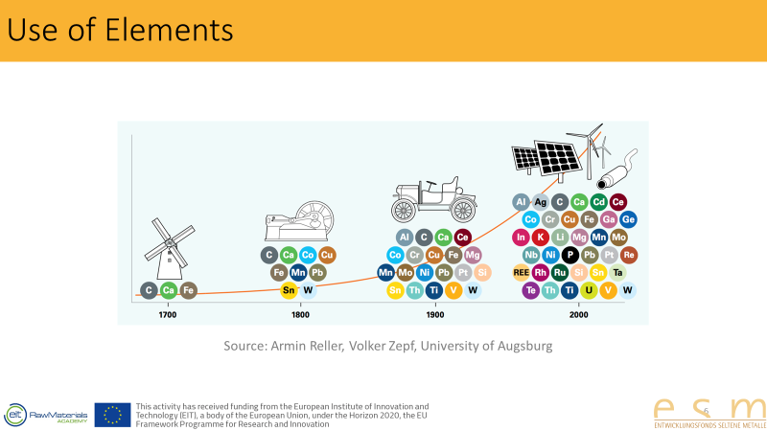 | - For thousands of years, we used only stone, wood and iron for our technology.  - With industrialisation around 1800 (in Western Europe), example Wolfram  - More complex machines like cars with more complicated parts  - Today, there is almost no element left which is not used in some industrial application
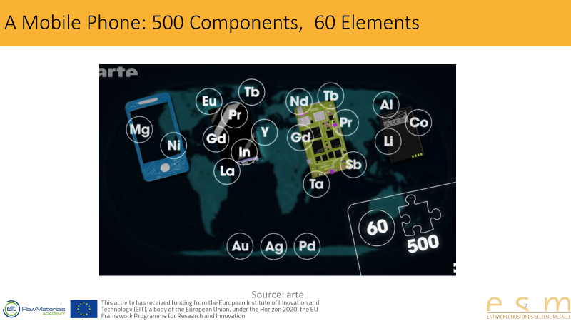 | - A single mobile phone consists of 500 components  - 60 different elements <- two thirds of the entire periodic table  - Known elements like silver and gold  - Less known elements like cobalt or tantalum
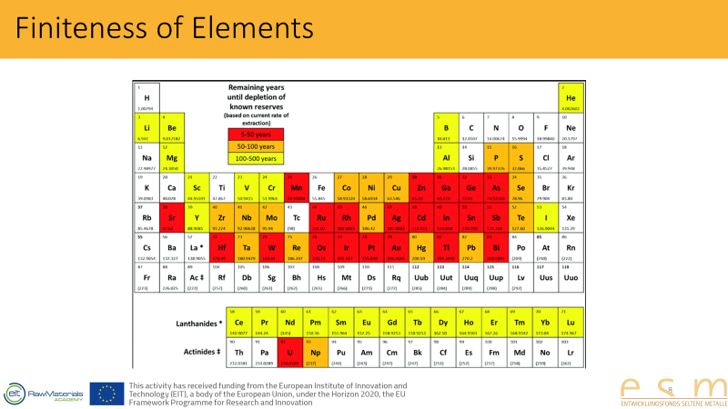 | - Availability  - E.e. aluminium is very common, we will have sufficient amounts of it for several hundreds of years. Silver and gold, however, are considered critical elements.  - Example of Indium and Germanium: very scarce  - Caution with assessments is required  - When demand for an element is especially high, the efforts to extract it will also increase  - Difference between resources and reserves  - CAVEAT: there are natural boundaries! If I extract a metal to generate electrical current, the extraction of the metal must not be more energy-intense than the electrical current I can generate with it.
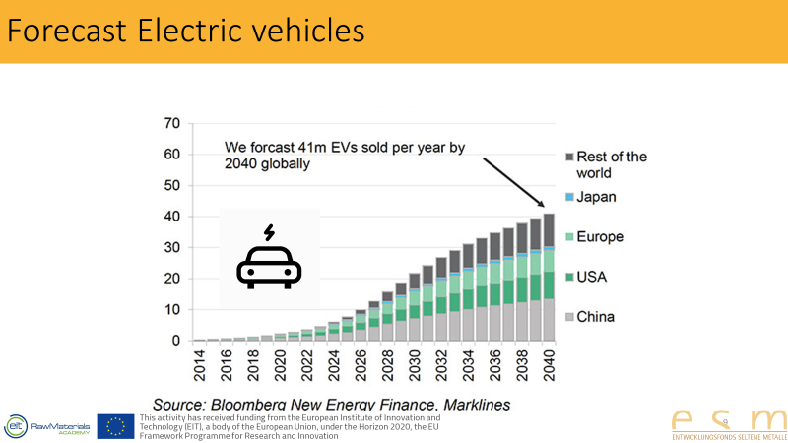 | - Electric cars require, inter alia, large amounts of Nickel and Cobalt.  - The latter is considered highly critical due to its high concentration (world reserves are almost entirely in the DRC)
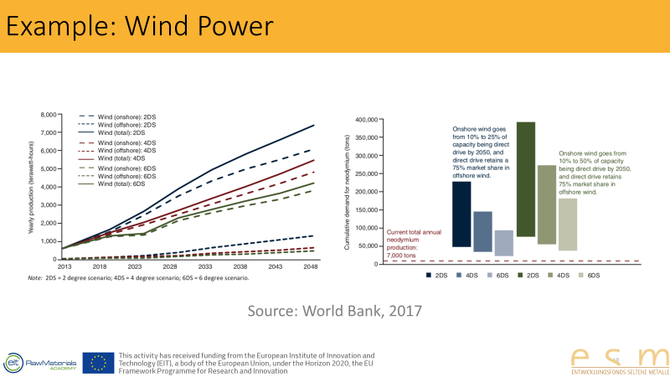 | - Climate scenarios  - Consumption of neodymium – a rare earth metal
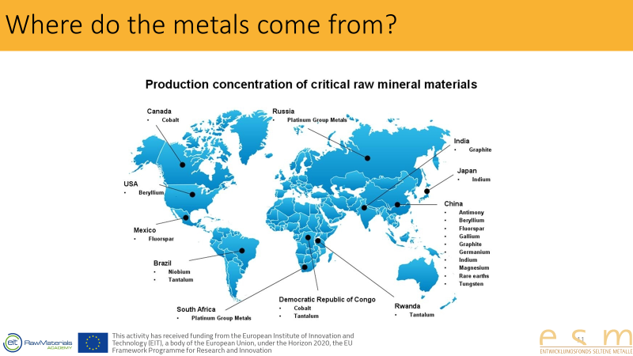 | Where do the metals come from?  - As you can see in this image, most metals are not sourced in Europe or even its immediate vicinity  - North America and Japan have some metal resources; otherwise, the countries most rich in resources are mostly developing countries  - We also see the Congo (DRC) here, an extremely poor African country. Tantalum, amongst others, is extracted here.  - China also deserves mentioning. With respect to many raw materials, we are dependent on China and its export policies. China introduced temporary export limits on certain elements which skyrocketed the price for these materials. In the current „trade war“ between the USA and China, one of the issues are „rare earths“, more than 95% of which are extracted in China.
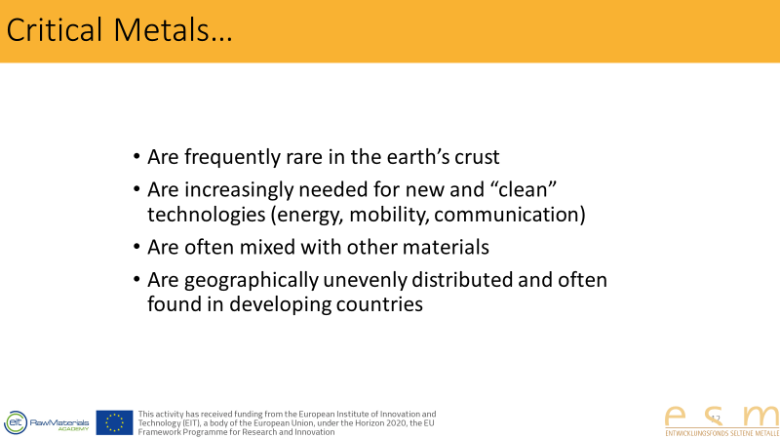
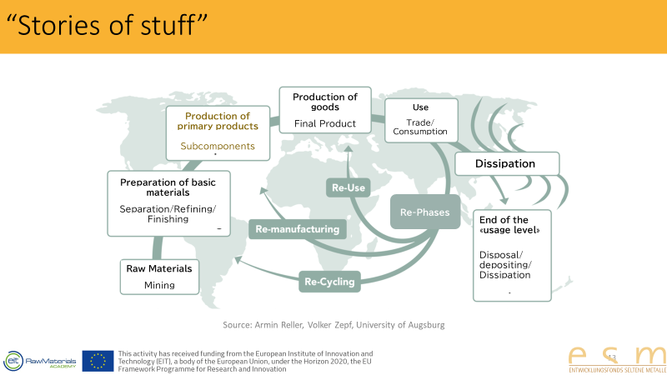 | - The „circle“ of an item from the beginning (mining) to the end, its end of life.  - Resources are processed into basic materials, from which primary products are made (e.g. a smartphone display); these primary products are combined with others to create the final product, whose raw materials at the end the product‘s life cycle are either dissipated into the environment or reused.  - One of the major problems contributing to materials‘ criticality is that a materials‘s inclusion into certain products decreases the concentration of this material on a global level; materials are heavily concentrated in mines first but then are dissipated into billions of e.g. smartphones. The concentration of certain materials in the end products is often so small that it is not economically feasible to recycle them.
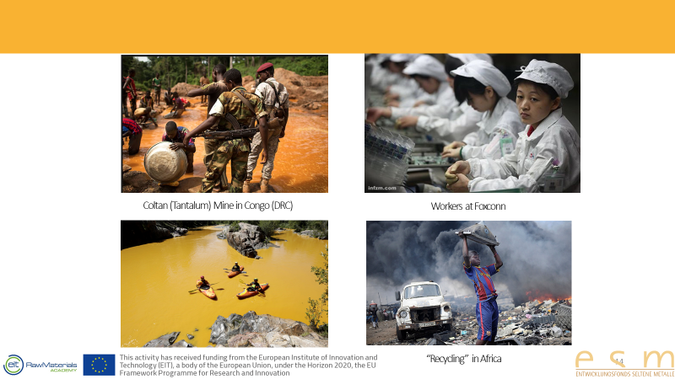 | - Besides the fact that elements are not infinitely available, the extraction and production of critical elements has often disastrous social and ecological consequences.  - 50-80% of electronic are deposed of in developing countries  - Recycling is often not profitable, because new production is cheaper
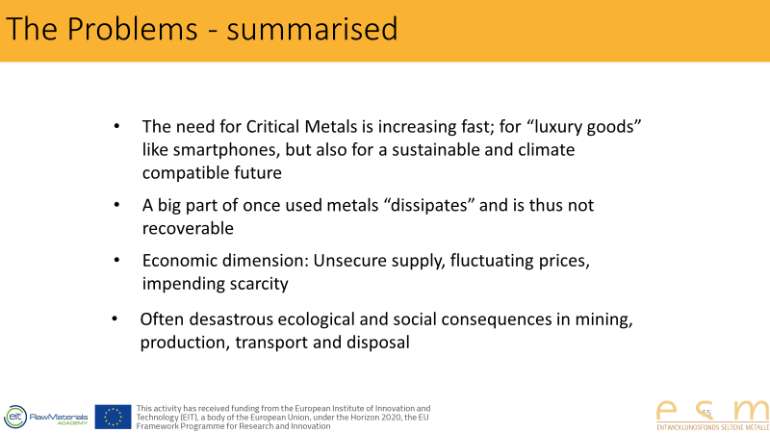
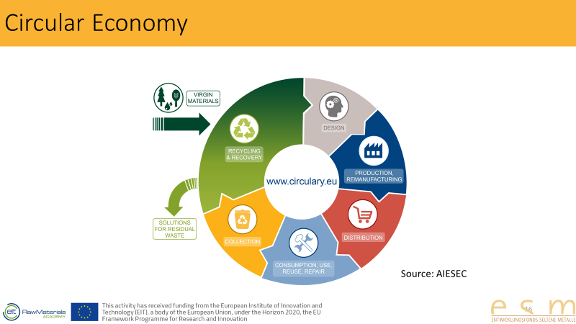 | - Politics has recognised the problem; the EC stated five years ago already that society needs to aspire to a circular economy, which means that fewer elements are lost in consumption, and more retained in the value chain.
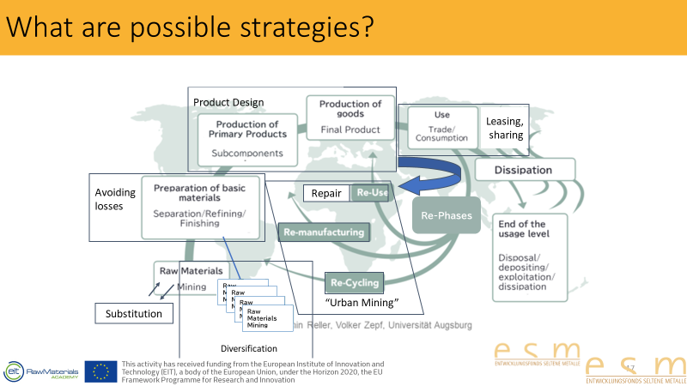 | - What happens to a smart phone which has been broken?  - You have it repaired, offer it to someone as a gift, sell it or donate it. In each of those cases, it is reused.  - You give it back to the manufacturer. If you are lucky and the manufacturer has a good recycling policy, he will disassemble the device.  - Into single components which are resused afterwards: „Re-manufacturing“  - Single metals which are used for new components: „Re-Cycling“
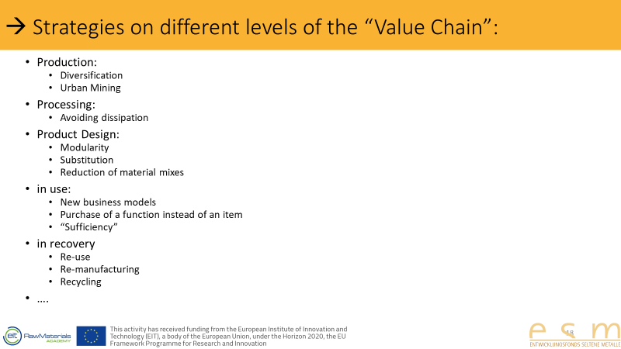

3. Exercise

4. Acknowledgements and Authors

This teaching material was prepared by Alessandra Hool from ESM Foundation.
The following authors have contributed to prepare the complete teaching material kit and intend to provide an overview of major topics surrounding the sustainable management of critical raw materials:
Ruud Balkenende, TU Delft
Stefano Cucurachi, Uni Leiden
Andrea Gassmann, Fraunhofer IWKS
James Goddin, Granta Design
Dominique Guyonnet, BRGM
Heinrich Hofmann, EPFL
Alessandra Hool, ESM Foundation
Amund Loevik, Empa
David Peck, TU Delft
Armin Reller, ESM Foundation
Antti Roine, Outotec
Dieuwertje Schrijvers, University of Bordeaux
Guido Sonnemann, University of Bordeaux
Layla van Ellen, TU Delft
Tatiana Vakhitova, Granta Design
Ester van der Voet, Uni Leiden
Patrick Wäger, Empa
Jan-Henk Welink, TU Delft
Steven Young, University of Waterloo
Besides, many others invested their time and expertise to discuss and review this teaching material.

5. Citation
Please cite the SusCritMat teaching material as follows when using them for your curriculum:
SusCritMat – Sustainable Management of Critical Raw Materials, funded by EIT RawMaterials, April 2017 – March 2020.

6. Disclaimer
The teaching materials within the SusCritMat project are still in development and undergo several revisions. We therefore currently provide only preliminary versions of teaching manuals, slides and exercises that will be finalized by the end of the project in early 2020.

